Wassup Seiya :^)

Fkn same bro

Wanna come woodward and jump off rooftop garden??

Get an uber

Hey VJ How ya doing boiii

OH rooftop garden is locked tho rippp, it’s after 23:00 :^(

Hell yeah

I’ll be nah lets just have fonts :^)

Thanks Seiya :^)

Big boi now hahahaha im better than u

Yo wtf seiya thats cheating

This font is called lobster lmao

Best font woop

I’m going green cus we’re gonna pass tomorrow :)

<https://www.youtube.com/watch?v=cycUHgg0zzU>

Mood

Moodation nation

:(

Wanna yeet myself off the gardens rn

Broskis i wanna fucking die

Helllll yeaaaaa but night tubEs arennt on :(

Too broke for that shit haha

Hi there VJ

Guys i got a big brain idea lets have our own font colors :)

Im purple omfg alex ure actually so cool boi im boutta do it yeah i saw that lmfao

Its pretty expensive font i’d say

Pass hahah i just hope van bakel’s gonna be lazy and copy questions again

Haha did u see question 1 in past papers it was identical 3 years in a row i just hope question 1 and 2 will be the same too this year haha

F O R T Y omg thats ambitious but i believe in you

Like fam we’re not getting tracked for personalized ads this is ***A M A Z I N G***

Okay like real talk tho dont y’all need to b studyin im about to fail

Good luck to y’all too :) okay lets put the size to one

Hope so too, I literaly just want 40 so i Never have to do discrete ever again

YO this is honestly the best social network, Zucc get onto this.

Where is our GOogle sheets concurrancy java lab

WAmen pls let that happen e can hope

Yeah we need to get that past paper grindd on WOOP

GOod luck bois

Also we should probably delete this shit

Or maybe just set it to Like size 1??

Yeah lmaooo Legit the same

Big oof

He literally used the same sets 3 years in a row lol

Let’s hope he’s as chill as thomas

Oh pls no more discreyeet

That’s a big brain idea right there

Nah who needs studying

Nah let’s just leave this all right here

It’s all good

Oh damm, that’s a hell of an idea

Wtaf

Damn apex is bringing out the big guns

Pass, yeah that’s not happening lmao

:^(

Hey there

/

Now i cant read what yall sayin but

Wait are we really leaving all that

Welp next years freshers can enjoy i guess

Might as well lol

Oh hey Rob

Hello there

General Kenobi, You are a bold one

1a)

i) A ∪ B = {2, 3, 4, 5, 7}, A ∩ B = {2, 7}

ii) A \ B = {4, 5}, B \ A = {3}

iii) A Δ B = {3, 4, 5}

iv) A × ∅ = ∅, A × (B \ A) = {(2, 3), (4, 3), (5, 3), (7, 3)}

1b)

i) (see notes Definition 2.12)

Reflexive : ∀x ∈ A (xRx)

Symmetric : ∀x, y ∈ A (xRy ⇒ yRx)

Transitive : ∀x, z ∈ A (∃y ∈ A (xRy ∧ yRz) ⇒ xRz)

ii)

R is reflexive ≜ ∀a ∈ A (aRa) ⟺ ∀a, b ∈ A (a idA b ⇒ aRb) ≜ idA ⊆ R

iii) R is symmetric ≜ ∀a, b ∈ A (aRb ⇒ bRa)

⟺ (def inverse) ∀a, b ∈ A (aRb ⇒ bR-1a)

⟺ R = R-1

iv) R ∘ R ⊆ R ≜ ∀a, b ∈ A (<a, b> ∈ R ∘ R ⟹ <a, b> ∈ R)

≜ ∀a, b ∈ A (a R ∘ R b⟹ a R b)

⟺ (def ∘ ) ∀ a, b ∈ A (∃ c ∈ A (aRc ∧ cRb) ⟹ aRb)

≜ R is transitive

1c)

i) (see notes Definition 4.10)

Surjective: ∀b ∈ B ∃a ∈ A (f(a) = b)

Injective: ∀a, a’ ∈ A (f(a) = f(a’) ⟹ a = a’)

Bijective: f is both injective and surjective

(see notes Exercise 4.39 for (ii) and (iii))

ii)

Let f : { a, b } -> { 1, 2, 3 } and g : { 1, 2, 3 } -> { c, d }

Then f = { <a, 1>, <b, 2> } and g = { <1, c>, <2, d>, <3, d> }

iii)

g ° f onto (surjective) implies for every c in C there exists (at least one) a in A such that (g ° f)(a) = c. (g ° f)(a) = g(f(a)) by definition.

Let’s assume g is not surjective. Then for some c in C there is no b in B such that g(b) = c. But we have already established that for every c in C there must be an a in A. Contradiction, hence g is surjective.

Alternative: <https://www.youtube.com/watch?v=bTKOC3Rst8c>

1d)

i) (see notes Definition 7.4)



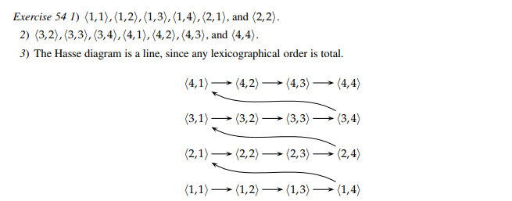

2a)

i) AF ⟶ CD ⟶ AG ⟶ AB ⟶ BC ⟶ (FG not chosen) ⟶ EF

ii) Yes because no two arcs have the same 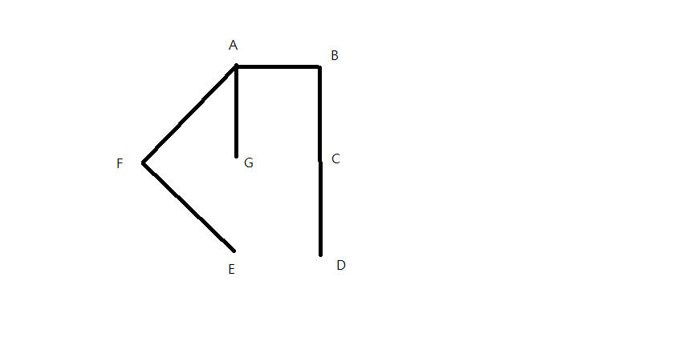 weight.

2b) Base Case : For n = 1, if G has 1 or more arc(s) there must be a cycle.

Assume true for n,

Take a graph G with n + 1 nodes and at least n + 1 arcs, if there is a node x with only one arc, then remove x and its arc to get to G’ with n nodes and at least n arcs. G’ must contain a loop. SInce G’ contains a loop, G must also contain a loop.

Alternative (non-inductive): Let G be a graph with n nodes and n arcs. If G is connected, then it is not a tree, so it contains a cycle. If G is not connected, then one of its connected components has at least as many arcs as vertices, s o this component is not a tree, therefore it contains a cycle.

2c)

i)

1—2

| |

4—3

ii)

1----2

| \ |

4 3

iii) If a belongs to a cycle in G, when a is removed, there must still be another path (go through the other way in the cycle) from x to y. So a cannot be bridge if it is in a cycle of G. (Therefore if a is a bridge, it cannot belongs to any cycle in G)

iv) The case with the maximum number of bridges would be when the graph is essentially a long chain as below:

1—2—3—4—…—n

It is clear this would then have n - 1 bridges.

Suppose we have a graph G with n nodes and n-1 bridges i.e. at least n-1 arcs. Now we try to add another bridge. There are now at least n arcs. By (b)) G has a cycle. By (c)iii)) all arcs in the cycle (at least one arc is needed to form a cycle) cannot be bridges so there are still at most n-1 bridges. Hence, there cannot be more than n-1 bridges.

ALTERNATE SOLUTION:

Loops and parallel arcs cannot be bridges. If a loop is removed, the graph cannot become disconnected as a loop is only incident on a single node. If a parallel arc is removed, there is at least one other arc with the same endpoints so the graph would still be connected. So, assume G is simple.  
By part iii), arcs that are part of a cycle cannot be bridges. So, a connected graph that has maximal bridges is a spanning tree. A spanning tree G with n nodes has n – 1 arcs. Removing any arc from a spanning tree disconnects the tree, so all arcs of a spanning tree are bridges.